USER FLOW BREAKDOWN
Book-a-Ride — Epics, Features & User Stories for Phase 1, Phase 2
Prepared by Rajat Pratap Singh Gaur · 19 September 2026
This document breaks the Book-a-Ride user flow into an Epic → Feature → User Story hierarchy, scoped to the first three phases of the rollout plan: Phase 1 (manual/concierge pilot), Phase 2 (automated single-rider MVP). Wireframes are placed directly under the story they illustrate. This is meant to be used as a Jira-ready backlog structure, not a narrative document.

Phase 1: Manual / Concierge Pilot
Goal: validate that users actually want ride help after booking a venue, using manual coordination — no automated booking infrastructure yet.

EPIC — Validate Ride Demand Through a Manual Pilot

As Playo, we want to test whether users want a ride-booking option after venue booking, using a low-cost manual process, before investing in engineering a full integration.

FEATURE — F1.1 — Capture Ride Interest Post-Booking

US-101 Ask if the user needs a ride after booking
As a user who just booked a venue, I want to be asked if I need help getting there, so that I don't have to separately go looking for ride options.
Acceptance Criteria:
- After a venue booking is confirmed, a prompt appears asking “Need help getting there?” with Yes/No options.
- This prompt only appears in the Phase 1 pilot city and sport.
- If the user selects “Yes,” their request (name, contact, game time, pickup area) is captured and sent to the ops team queue.
- If the user selects “No,” no further action is taken and the booking flow completes normally.
Edge Cases:
- User already marked “Own vehicle” elsewhere in the game details — prompt should not appear, or should note this to avoid a confusing duplicate ask.
- User is booking outside the Phase 1 pilot city/sport — prompt must not appear at all.
- User selects “Yes” but closes the app before their contact details are captured — request should not be logged as complete.
- User submits a request extremely close to game time (e.g. under 30 minutes) — should be flagged separately since manual coordination may not be possible in time.

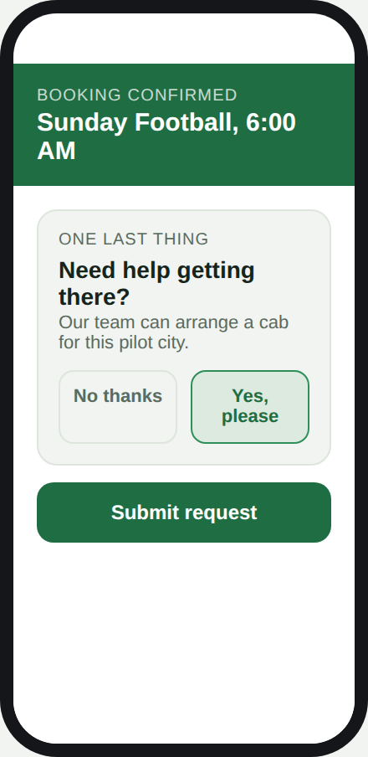
Post-booking ride prompt

FEATURE — F1.2 — Manual Ride Coordination

US-102 Confirm the request was received
As a user who requested a ride, I want confirmation that my request was received, so that I know Playo is handling it and I don't need to arrange my own ride.
Acceptance Criteria:
- After submitting a ride request, the user sees a confirmation screen stating a team member will reach out within a set time window (e.g. 2 hours).
- The confirmation clearly indicates this is a manual/pilot process, not an instant booking.
Edge Cases:
- Ops team fails to respond within the promised window — need an internal alert/escalation so the user isn't silently left waiting.
- User provides an invalid or unreachable phone number — request should fail validation before being queued, not after.
- User submits multiple ride requests for the same game (e.g. taps twice) — should be deduplicated rather than creating two ops tickets.

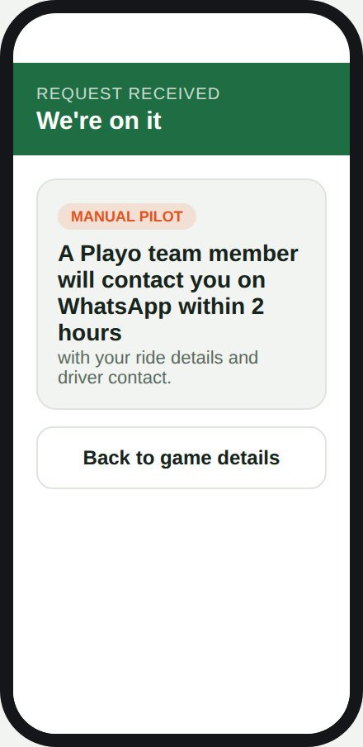
Request received confirmation

US-103 Receive ride details manually via WhatsApp
As a user who requested a ride, I want to receive my driver and pickup details over WhatsApp, so that I have everything I need without opening a separate app.
Acceptance Criteria:
- Ops team manually books a cab with a local vendor and sends driver name, vehicle number, and pickup time via WhatsApp.
- Message is sent at least 30 minutes before the scheduled pickup time.
- Fare and payment method (e.g. pay driver directly) are clearly stated in the message.
Edge Cases:
- User doesn't have WhatsApp installed or provided a non-WhatsApp number — need a fallback channel (SMS/call).
- Local vendor cannot fulfil the request (no driver available) — user must be notified well before pickup time, not left waiting.
- Driver cancels last-minute after the WhatsApp message was already sent — ops needs a re-booking process and a way to re-notify the user quickly.
- User doesn't respond to confirm they've seen the message — should ops still proceed, or attempt a follow-up call?

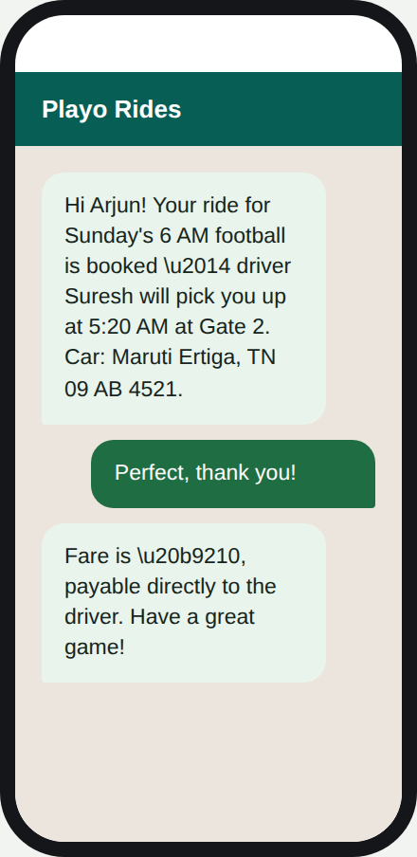
WhatsApp ride confirmation

FEATURE — F1.3 — Pilot Measurement

US-104 Track pilot demand internally
As a product team, we want to log every ride request during the pilot, so that we can measure real demand before building automation.
Acceptance Criteria:
- Every ride request (accepted or declined) is logged with game time, pickup area, and outcome.
- Weekly summary of request volume and fulfillment rate is available to the product team.
- Data collected here directly feeds the go/no-go decision for Phase 2.
Edge Cases:
- A request is logged but the outcome (fulfilled/not fulfilled) is never updated by ops — need a required close-out step so data doesn't go stale.
- Same user requests rides for multiple different games in the same week — should count as separate data points, not deduplicated across games.
- A request is cancelled by the user after being logged — needs its own status rather than being counted as “not fulfilled.”

FEATURE — F1.4 — Payment (Cash/UPI to Driver)

Phase 1 has no in-app payment at all. This is intentional — building a payment integration is exactly the kind of engineering investment the manual pilot is designed to avoid until demand is proven.

US-105 Know how and when I'll pay for my ride
As a user with a manually-arranged ride, I want to know upfront how I'll pay, so that I'm not caught off guard when the driver arrives.
Acceptance Criteria:
- The WhatsApp confirmation (US-103) explicitly states the fare and that payment is made directly to the driver — cash or UPI — at the end of the ride.
- No payment is collected by Playo at any point during the Phase 1 flow.
- The stated fare is an estimate; the final amount is agreed with the driver directly, consistent with how the local cab vendor normally operates. Who will negotiate with the driver?
Edge Cases:
- User expects to pay through the Playo app (since they paid for the venue that way) and is confused when told to pay the driver directly — messaging must make this very explicit, not assumed to be understood.
- Driver and user disagree on the final fare at the end of the ride — Playo ops has no visibility or role in resolving this during Phase 1, which should be flagged as a known limitation.
- User has no cash and the driver doesn't accept UPI — should be surfaced as a data point for whether Phase 2 payment needs to support multiple methods.

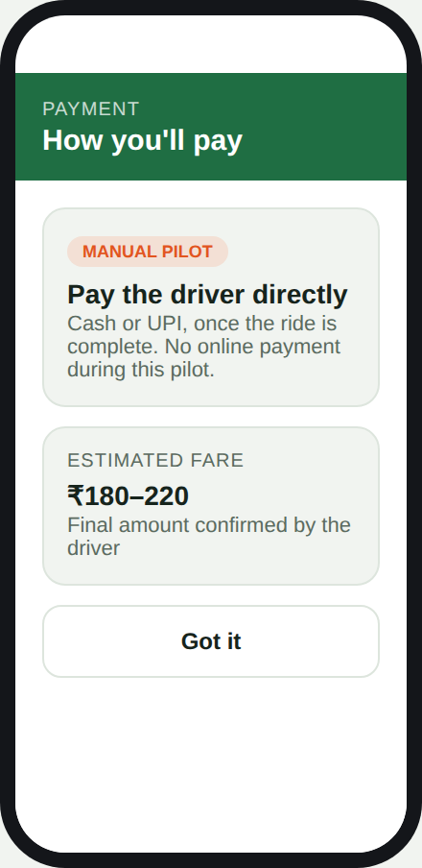
Payment info — pay driver directly

FEATURE — F1.5 — Cancellation & Rescheduling

Since Phase 1 has no automated link between the venue booking and the ride request, a cancelled or rescheduled game does not automatically update the ride request. This story defines the manual process needed to prevent a driver being sent for a game that no longer exists at its original time.

US-106 Cancel or reschedule my ride request when my game changes
As a user who requested a ride and then cancels or reschedules the game, I want my ride request to be updated or cancelled too, so that a driver isn't arranged for a game that's changed.
Acceptance Criteria:
- If the linked venue booking is cancelled, the ride request is automatically flagged as cancelled in the ops queue.
- If the linked venue booking is rescheduled (date/time changed), the ride request is automatically flagged as “needs re-confirmation” rather than silently kept at the old time.
- If a driver has already been arranged with the local vendor at the time of cancellation/reschedule, ops is alerted immediately so they can cancel or re-coordinate with the vendor.
- The user receives a WhatsApp message confirming their ride request has been cancelled or is being re-arranged for the new time.
Edge Cases:
- Game is cancelled or rescheduled after the WhatsApp confirmation (US-103) has already been sent and the driver is en route — needs an urgent manual cancellation path, since standard queue processing may be too slow.
- User reschedules the game but doesn't realize they need to also confirm the new ride time — message should explicitly ask them to reconfirm, not assume silence means “still needed.”
- Local cab vendor charges a cancellation fee for a last-minute change — needs a clear internal policy on whether Playo absorbs this cost during the pilot.
- Game is rescheduled to a time/date outside the Phase 1 pilot window (e.g. moved to a city or sport not covered) — ride request should be cancelled outright rather than re-confirmed.
End-to-end Phase 1 flow: venue booked → ride requested (US-101) → request confirmed (US-102) → payment expectations set (US-105) → driver/ride details sent via WhatsApp (US-103) — this WhatsApp message is the user's “booking confirmed” moment in Phase 1, since there is no in-app confirmation screen.

Phase 2: Automated MVP (Single-Rider)
Goal: replace manual coordination with a real third-party ride integration, for single riders only, once Phase 1 shows healthy demand.

EPIC — Automate Single-Rider Ride Booking

As Playo, we want users to book and pay for a ride directly within the app through a third-party ride partner, so that the experience is instant and doesn't rely on manual ops effort.

FEATURE — F2.1 — Ride Prompt & Fare Estimate

US-201 See a live fare estimate after booking
As a user who just booked a venue, I want to see an estimated fare for a ride to the venue, so that I can decide whether to book one.
Acceptance Criteria:
- After venue booking, a card appears showing an estimated fare range based on the user's location and the venue address.
- Estimate is pulled live from the third-party ride partner's API.
- User can tap “See ride options” or dismiss with “Not now.”
Edge Cases:
- Ride partner API is down or times out — card should fail gracefully (e.g. hide the ride prompt) rather than show a broken/blank estimate.
- User has denied location permission — fare can't be estimated; prompt should ask for location or fall back to a manual pickup-address entry.
- Venue is outside the ride partner's service area — no fare should be shown, and the feature should not appear at all for that booking.

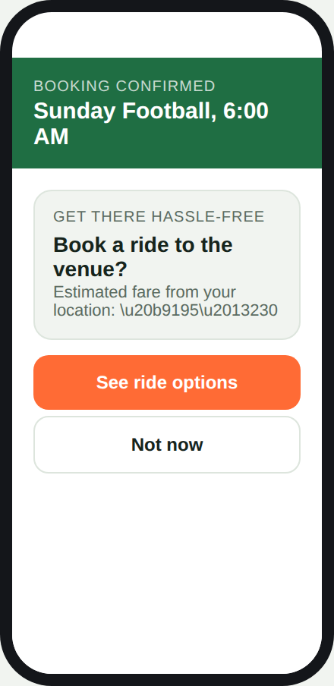
Ride prompt with fare estimate

FEATURE — F2.2 — Ride Selection & Booking

US-202 Choose between ride options
As a user who wants a ride, I want to compare a couple of ride types (e.g. Standard, Auto) with price and pickup time, so that I can pick the one that suits me.
Acceptance Criteria:
- At least two ride options are shown, each with price, vehicle type, and estimated pickup time.
- User can select a ride option with one tap and proceed to payment.
- Selecting an option does not yet book the ride — booking only happens after payment succeeds (see F2.2b).
Edge Cases:
- No drivers are available at that time (common for very early-morning games) — user should see a clear “no rides available” message, not a stuck loading screen.
- Price shown here differs from the fare estimate in US-201 — acceptable within a small tolerance, but the final price must be re-confirmed at payment.
- User backs out mid-selection (app closed, network drop) — no ride should be booked, and no charge should occur.

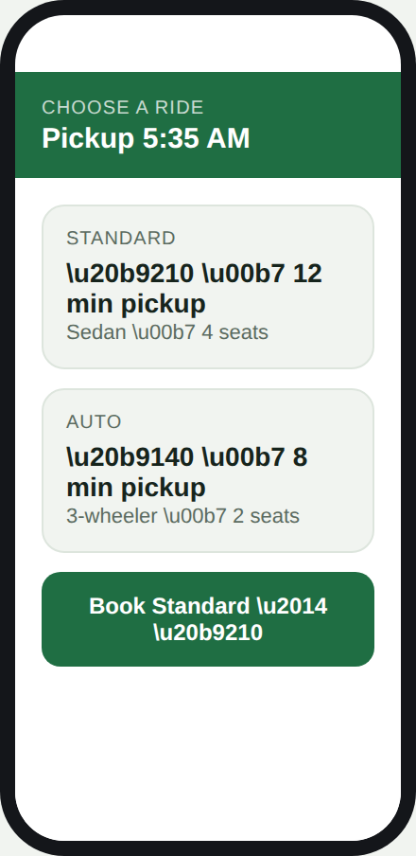
Ride options screen

FEATURE — F2.2b — Payment & Booking Confirmation

This is the step-by-step payment process, ending with the message that tells the user their booking is confirmed.

US-206 Pay for my ride with a saved payment method
As a user who selected a ride, I want to pay using a saved payment method (UPI or card), so that I don't have to handle cash or enter payment details every time.
Acceptance Criteria:
- A “Confirm & Pay” screen shows the ride summary (pickup time, location, vehicle type) and the user's default saved payment method.
- User can change the payment method before confirming, if more than one is saved.
- Tapping “Pay ₹[amount] & Book” initiates the charge through the third-party ride partner's or Playo's payment gateway.
- The exact fare shown here is the amount that will be charged — no hidden fees added at this step.
Edge Cases:
- User has no saved payment method — must be prompted to add one before this screen, not left stuck on a screen with no way to pay.
- User's saved card/UPI fails or is declined — booking must not proceed; user is shown a clear error and asked to retry or pick another method.
- User backs out or closes the app while payment is processing — the ride must not be booked unless the charge is confirmed successful; a pending charge should be auto-reversed if the booking fails.

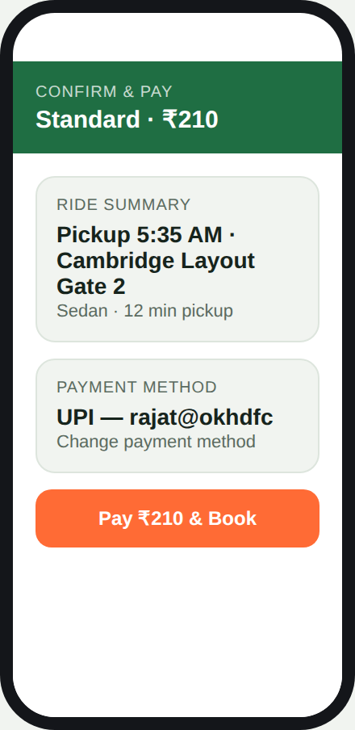  Confirm & pay | 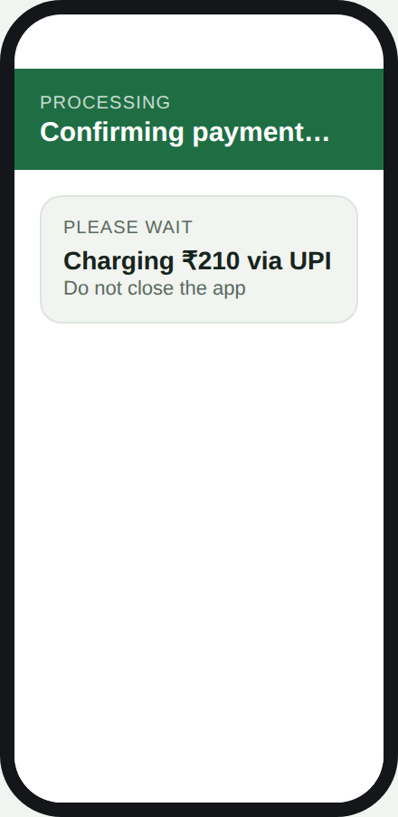  Payment processing

US-207 Get a clear booking confirmation after payment
As a user who just paid for a ride, I want an unmistakable confirmation that my booking is complete, so that I know I don't need to do anything else.
Acceptance Criteria:
- Once payment succeeds, the user is shown a “Booking Confirmed” screen with a success indicator, the amount charged, and the payment method used.
- A receipt is sent to the user's registered email/notification center.
- The screen also shows the ride is being matched with a driver, and transitions into the live tracking screen (US-203) once a driver is assigned.
- This confirmation screen is the definitive “booking confirmed” moment in Phase 2 — equivalent to the WhatsApp message in Phase 1 (US-103), but instant and in-app.
Edge Cases:
- Payment succeeds but no driver can be matched afterward — user must be automatically refunded and clearly notified, not left with a paid-for ride that never arrives.
- User doesn't see the confirmation screen due to an app crash or connectivity loss right after paying — confirmation and receipt must also be delivered via push notification/SMS as a backup.
- Duplicate payment is accidentally triggered (e.g. double-tap on “Pay & Book”) — must be prevented at the payment-gateway level so the user is never charged twice for one ride.

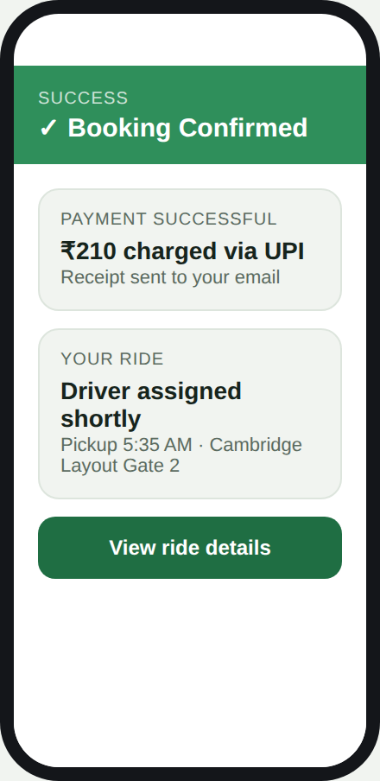
Booking confirmed

FEATURE — F2.6 — Ride Cancellation

US-208 Cancel my ride after booking it
As a user with a confirmed ride, I want to cancel it if my plans change, so that I’m not left with a ride I no longer need and I understand what it will cost me.
Acceptance Criteria:
- A “Cancel ride” option is visible from the live tracking screen (US-203) at any point before the driver arrives.
- Before confirming cancellation, the user is shown whether a cancellation fee applies and the amount, based on how close to pickup time or how far the driver has already travelled.
- Once cancelled, the ride status updates immediately to “Cancelled” and the user sees a confirmation with any fee charged and the reason for it.
- If a cancellation fee applies, it is charged to the same saved payment method used for booking (US-206); if no fee applies, no charge is made.
Edge Cases:
- User cancels within seconds of the driver being assigned — no fee should be charged if this falls within a short free-cancellation grace period.
- User cancels after the driver is already near the pickup point — a higher fee tier should apply, and this must be clearly shown before the user confirms.
- User cancels but the cancellation request fails to reach the ride partner’s API (network drop) — the app must retry and show a pending state, not silently leave the ride active with a driver still en route.
- User cancels a ride that’s part of a game the venue booking for which is also being cancelled at the same time — both cancellations should be handled without double-charging or leaving one system out of sync with the other.
- Driver has already started the trip (picked up the user) — cancellation should no longer be allowed from this screen; the flow should redirect to an in-ride support/help option instead.

End-to-end Phase 2 flow: venue booked → fare estimate shown (US-201) → ride option selected (US-202) → payment method confirmed and charged (US-206) → “Booking Confirmed” message shown with receipt (US-207) → driver assigned and live-tracked (US-203) → ride completed and rated (US-204).
FEATURE — F2.3 — Live Ride Tracking

US-203 See my driver and pickup details
As a user with a confirmed ride, I want to see my driver's name, vehicle, and pickup point, so that I know who to look for and where to wait.
Acceptance Criteria:
- Once booked, a confirmation screen shows driver name, rating, vehicle number, and pickup location.
- ETA updates in real time based on the partner API.
- User can message the driver directly from this screen.
Edge Cases:
- Driver cancels after being assigned — user must be notified immediately and automatically rematched or shown how to rebook.
- Driver is significantly delayed beyond the original ETA — screen should update the ETA rather than show a stale, now-incorrect time.
- App loses network connectivity mid-tracking — last-known driver info should still display, with a clear “reconnecting” state rather than going blank.
- User needs to cancel the ride after booking — needs a visible cancel option, and should be told if a cancellation fee applies.

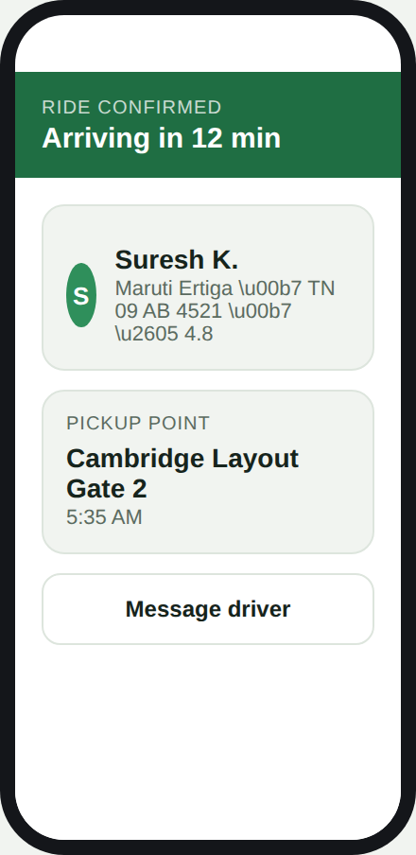
Ride confirmed with driver details

FEATURE — F2.4 — Post-Ride Feedback

US-204 Rate my ride after it's complete
As a user who just completed a ride, I want to rate the driver, so that Playo can monitor ride quality across the partner network.
Acceptance Criteria:
- After the ride ends, a rating screen appears with a 5-star selector and the final fare charged.
- Rating is submitted to Playo's own database (not just the ride partner's), so Playo can track quality independently.
- Ratings feed into the Success Metrics defined in the main project brief (Section 5: Success Metrics).
Edge Cases:
- User closes the app before rating — should be prompted again next time they open the app, but not blocked from using it in the meantime.
- Ride was cancelled mid-way (by driver or user) rather than completed — rating screen should not appear, or should be replaced with a shorter “what went wrong” prompt.
- Final fare differs from the originally quoted fare (e.g. traffic/route change) — screen must show the actual charged amount, not the original estimate. Show the same amount to be charged as it is deducted from the saved payment method.

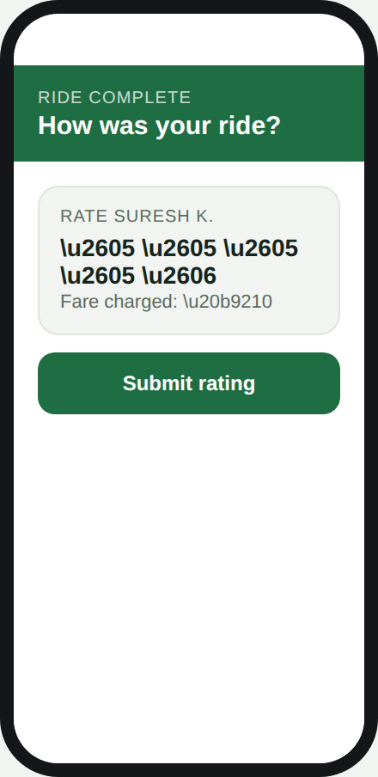
Post-ride rating screen

FEATURE — F2.5 — MVP Measurement

US-205 Track ride attach rate automatically
As a product team, we want ride bookings to be automatically tracked against venue bookings, so that we can measure ride attach rate without manual logging.
Acceptance Criteria:
- Every venue booking is tagged with whether a ride was also booked.
- A dashboard shows ride attach rate, average fare, and completion rate updated daily.
- This replaces the manual weekly summary used in Phase 1 (US-104).
Edge Cases:
- A ride is booked but later cancelled or refunded — dashboard must distinguish this from a successfully completed ride, not count it as a plain “attach.”
- Ride partner API reports a booking with a delay (data arrives late) — dashboard should reconcile late-arriving data rather than show a permanently incomplete daily total.
- A user books a ride through the ride partner's own app separately (outside Playo) — this should not be counted toward Playo's attach rate at all.

